**Fairfield by Marriott Bogota Embassy Hotel**

**welcomes you to the SIM METROLOGY SCHOOL**

The hotel is located on La Esperanza Avenue No. 51-40, in the most important business area of the city, just 15 minutes from El Dorado International Airport, 5 minutes from the Corferias Fair and Exhibition Center, Agora, near the National Administrative Center CAN, the Government of Cundinamarca, the Attorney General's Office, the industrial zone of Montevideo, the Gran Estación Shopping Center and the American Embassy.

[www.marriott.com/es/hotels/bogfi-fairfield-bogota-embajada/overview/](http://www.marriott.com/es/hotels/bogfi-fairfield-bogota-embajada/overview/)

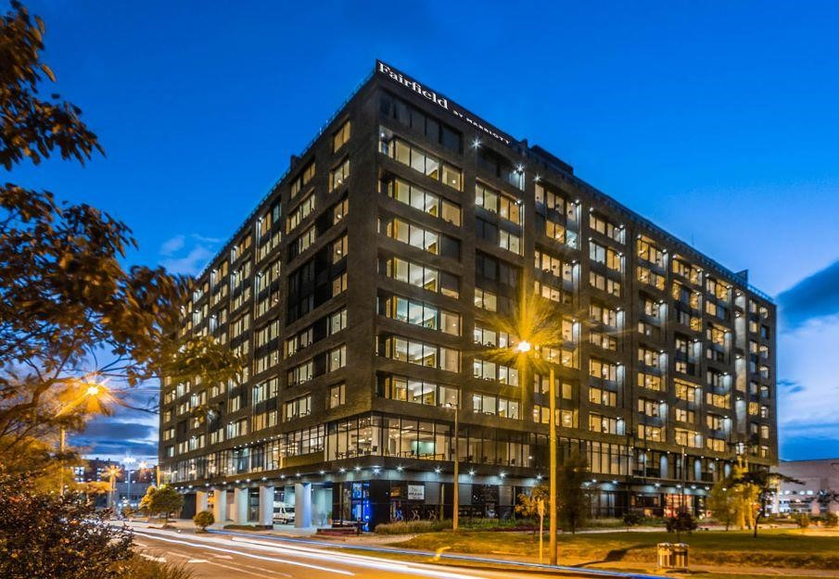

Your rate includes:

* Buffet breakfast at the restaurant.
* Shuttle Airport - Hotel - Airport, in schedules established by the hotel.
* Gym (Basement 1) Cardio area, Strength.
* Permanent wired Internet (High Speed) and Wi-Fi in the room.
* 24-hour Business Center with printing center.
* Security box, air conditioning and building with bioclimatic ventilation system.
* Covered parking.

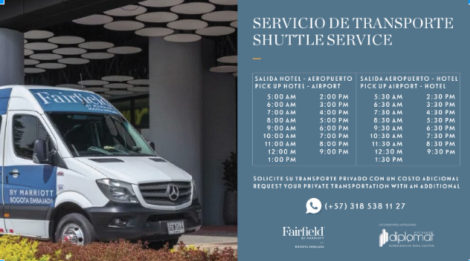

Additional services (not included in the rate):

* Room Service 24Hrs
* Market Service 24Hrs
* Restaurant.
* Bar.
* Laundry.
* Private transportation: if required, please write to the following e-mail: [coordinaciontransportes@stafftransportes.com](mailto:coordinaciontransportes@stafftransportes.com) where you must send your personal information, flight information (if necessary) and contact telephone number.
* Local, national and international calls.